** STREAM:**

**Resilience**

we’d greatly appreciate your use of this qr code to record attendance for this HRSA funded program



1. **Introduction to Total Well-Being**

PARTNER ACTIVITY: listen for qualities you hear, no need to write

INDIVIDUAL ACTIVITY: PERMAH Wheel

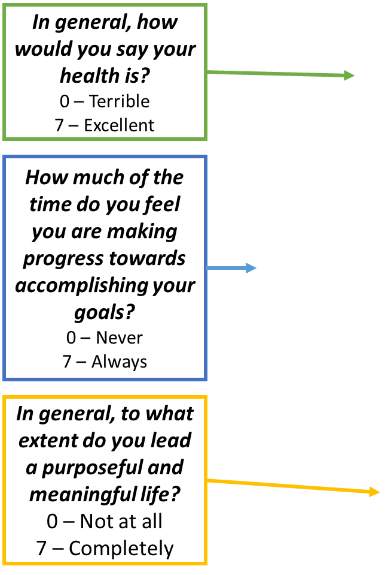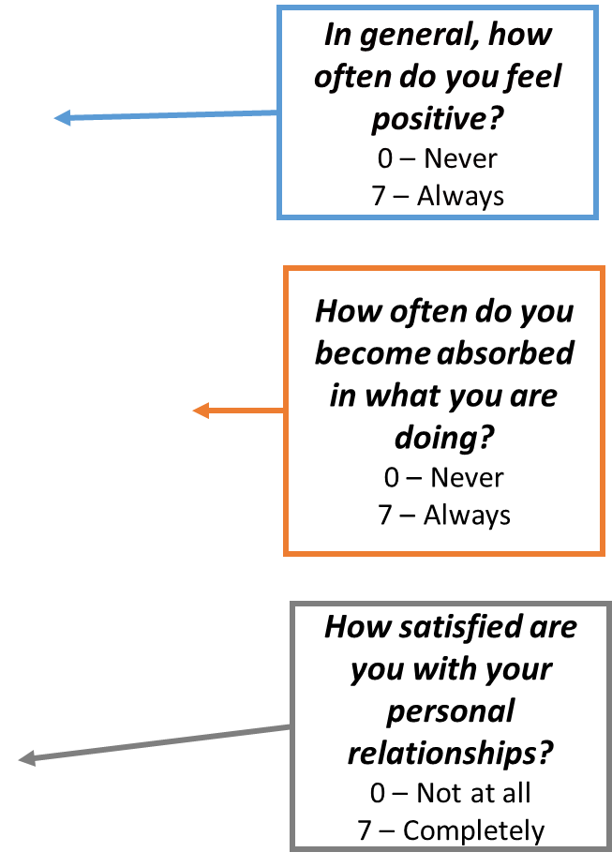 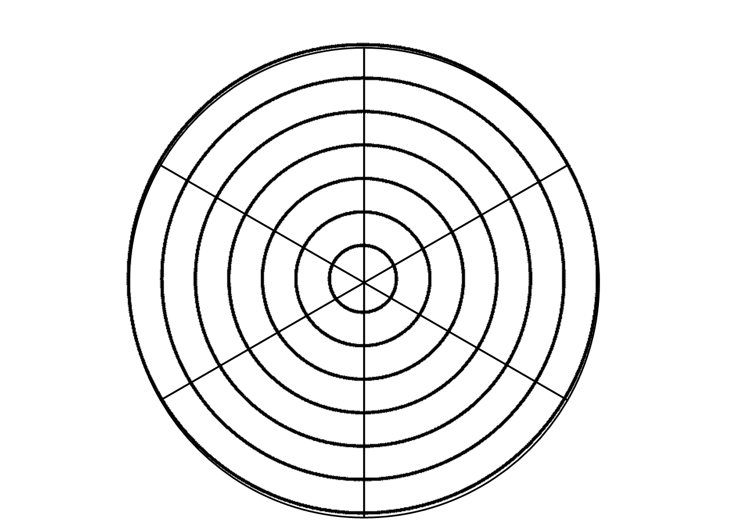

Reflection Discussion: did anything surprise you?

**What’s next?**

1. ***How much time*** do you have to devote to one or two of the above areas?

5-10 mins / 30 mins / 1 hour

1. ***What specifically*** would you be doing in one or two important domains?
2. ***When specifically*** can you do these things?

**2. Finding Your Values Compass**

PARTNER ACTIVITY

**Speaker questions to answer:** Why do you do the work that you do? What brings you energy and joy? Who do you most admire and why? What traits do you want to be known for? What do want to be said at your retirement party?

**Listener:** What values do you notice as you listen to your partner?

INDIVIDUAL ACTIVITY: Values Clarification

**Example Values**

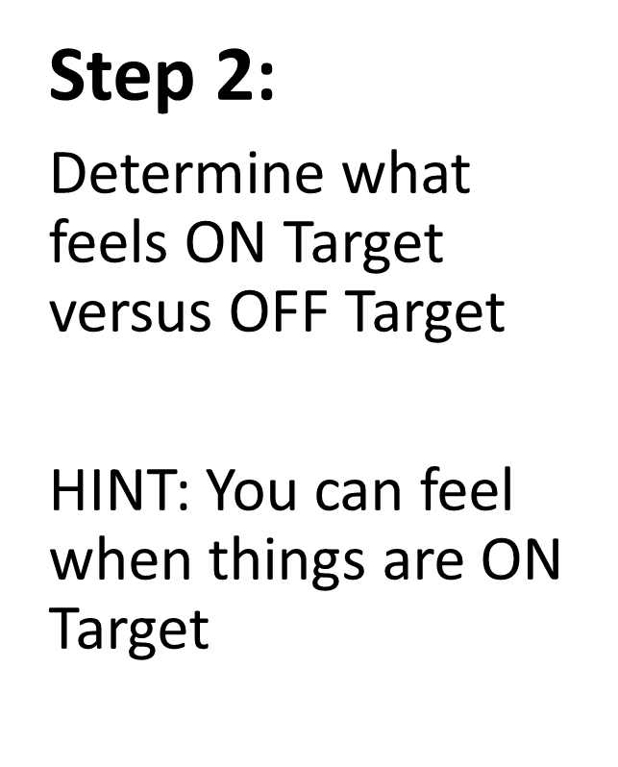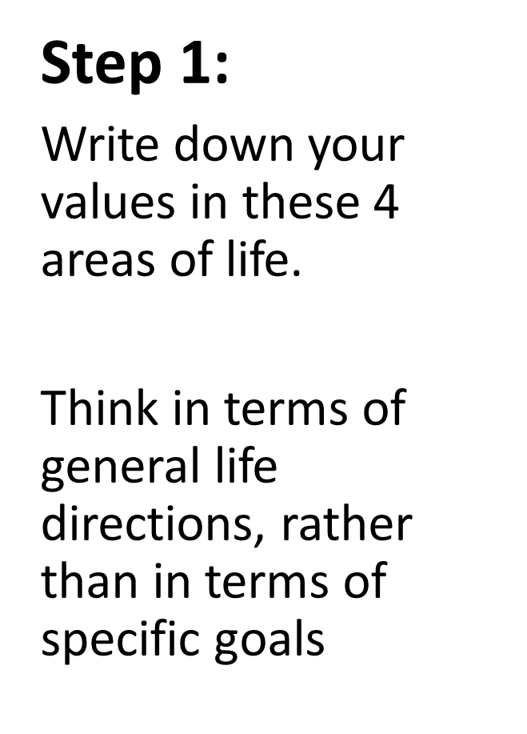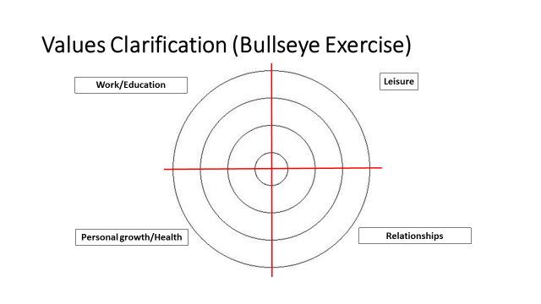

1.

2.

3.

4.

1.

2.

3.

4.

1.

2.

3.

4.

1.

2.

3.

4.

**Ambition**

**Achievement**

**Adventure**

**Bravery**

**Authenticity**

**Community**

**Compassion**

**Competency**

**Connection**

**Curiosity**

**Creativity**

**Dependability**

**Empathy**

**Equity**

**Honesty**

**Humor**

**Integrity**

**Joy**

**Knowledge**

**Justice**

**Leadership**

**Loyalty**

**Optimism**

**Peace**

**Punctionality**

**Respect**

**Responsibility**

**Service**

**Trust**

**Understanding**

**Wisdom**

Debrief: using values to assist in making decisions

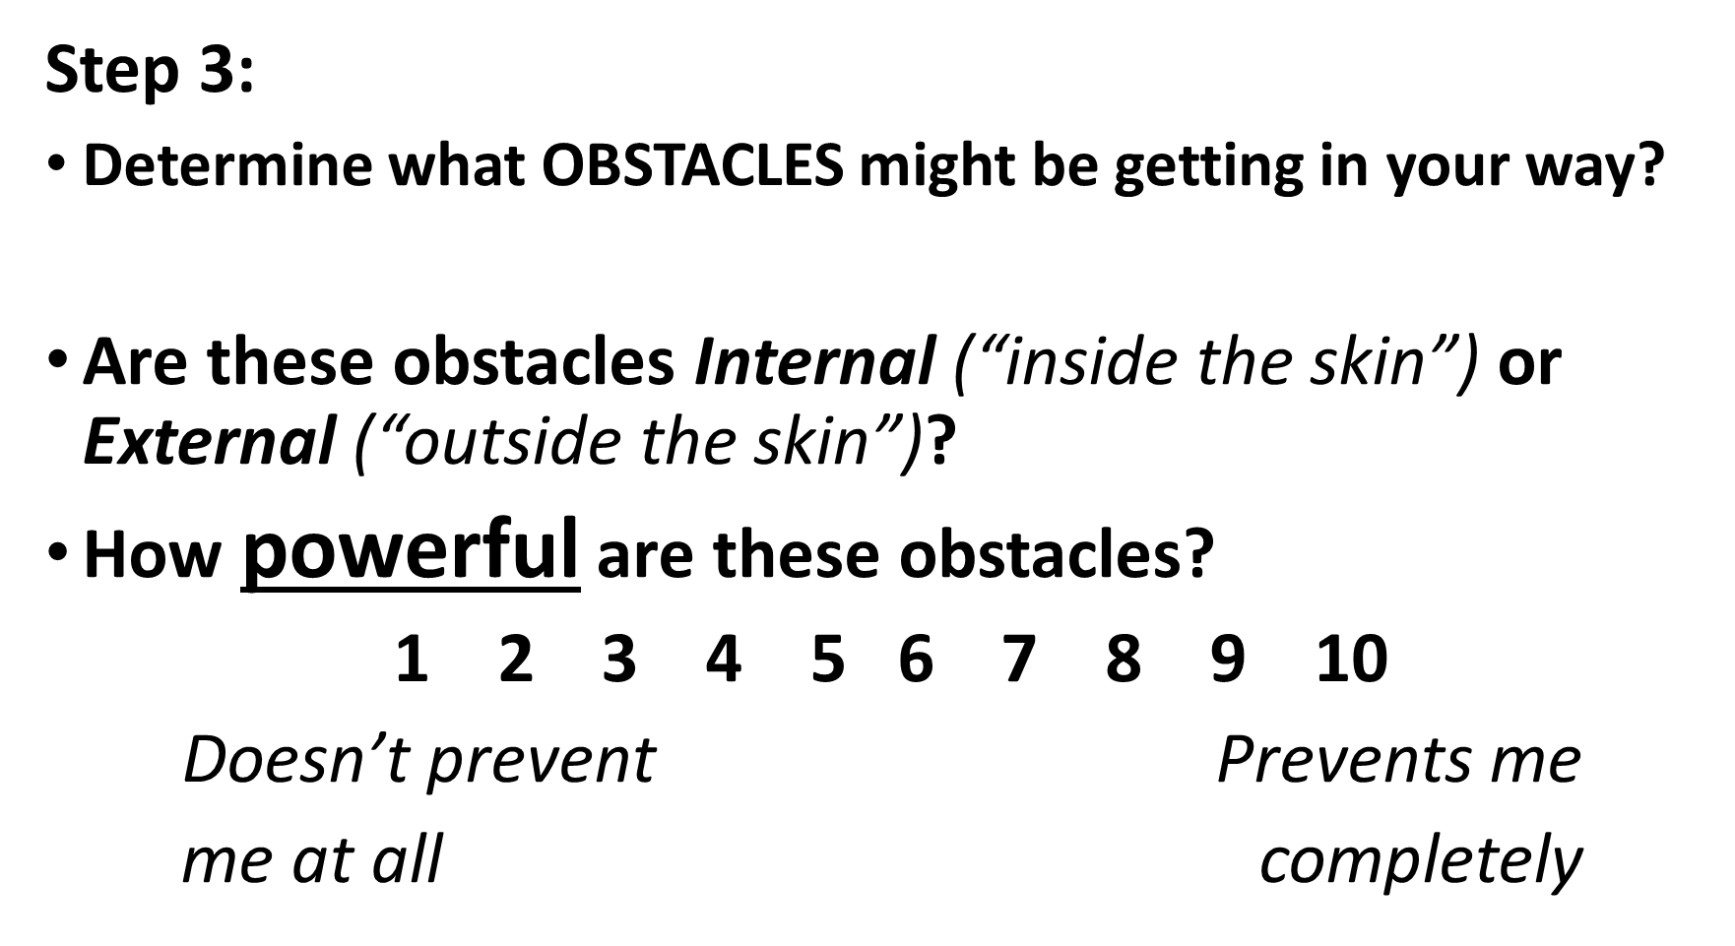

1 2 3 4 5 6 7 8 9 10

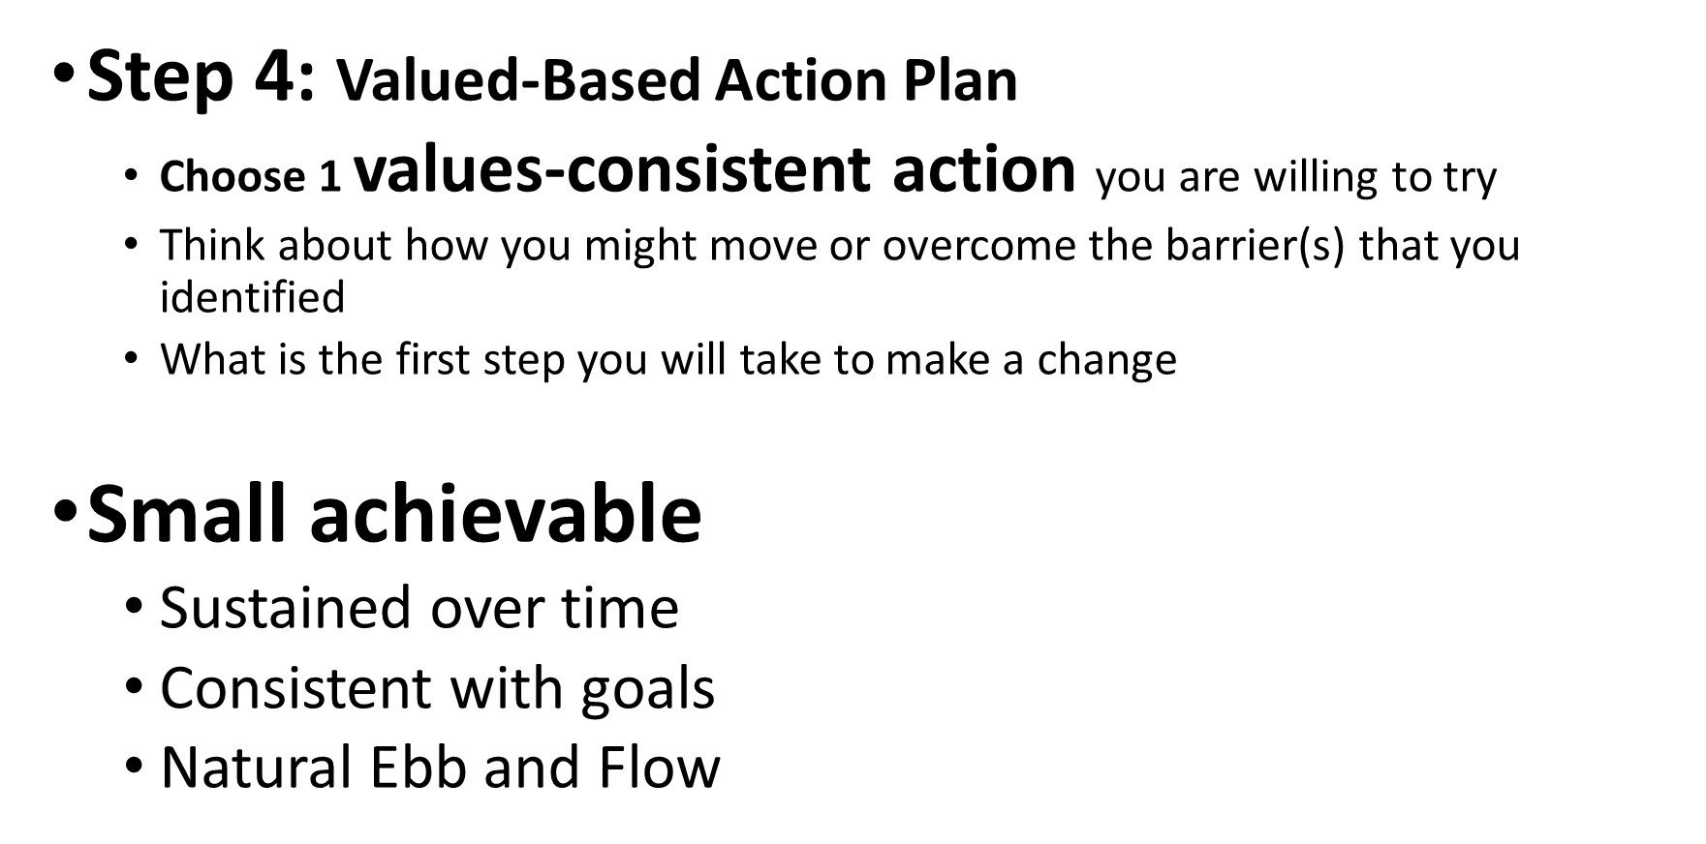

My values-consistent action is… ___________

The first step I will take to make a change is…

Thank You

We’re so glad you could be part of this program with us today. Thank you for your participation!

Please help us out by completing this 6 question evaluation today! We’d love your input re:

Content relevancy, DEI incorporation, interactiveness of session, facilitator effectiveness, likelihood to recommend, and an open ended section for anything you’d like to note.

You’ll receive a follow up survey in two weeks. We’d love your feedback!

Brief Eval



Extra Resources Available to You

STREAM Resource Library

There are extra STREAM resources and activities available for your use on our site as well.  We have more videos, worksheets, and other links that you may find beneficial.  Check them out here:

note: these materials are available for anyone with a STREAM account

Resources



STREAM App

Download our app, available for free

Apple: Android:

 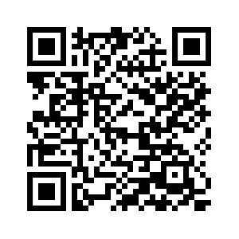

Features

-Buddy chat (anonymous capability)

-Goal setting and tracking

-Journaling

-Links to extra STREAM resources on the app

-Opportunity to provide feedback for STREAM programming

Follow us on Twitter: STREAM@elms